

To be included in 5.1.2.01 & 9.1.1.01
OPUS SPC/BKG "Standby" Function

CAUTION!
If you are holding a hard copy of this document, beware that it is maintained on a cloud based solution and that it may not be the latest version.
Hard copies are not encouraged to use.

Version Control
Ver | Date  (DD.MM.YYYY) | BP Author (Office/Region) | Revision Notes
1.0 | 26.03.2019 | Jessie Wang (GHQ SYM BI)
1.1 | 20.11.2019 | Jessie Wang (GHQ SYM BI) | Added G.RFA in 1.4.1.2
1.2 | 11.10.2021 | Wan Yan Sia (GHQ DYM BPM) | Updated Roles in 1.3  Added Creation of G.RFA in 1.4.1.3  Added ONE Quote Standby Functions in 3  Updated Launch Status – Countries and Trades in 4.2.2
1.3 | 24.03.2022 | Wan Yan Sia (GHQ DYM BPM) | Updated Standby Priority Set-up Creation in 1.4.1.2  Added Sequential Validation in 1.4.1.3  Added Standby Revalidation Logic in 1.4.1.4  Updated Booking Status Definition in 1.4.1.5  Updated Master Constraint Table Creation in 1.4.1.6  Updated Weight Allocation and Added Validation Error Pop-out Table in 1.4.1.6  Updated Creation of Group RFAs in 1.4.1.7  Added Standby Hardcoding Table for Pre/Post Feeder in 1.4.1.8  Updated Standby Booking Role Setup in 1.4.2.1  Added link to ONE Quote Standby Set-up Guideline in 4.1
1.4 | 29.12.2022 | Wan Yan Sia (GHQ DYM BPM) | Removed Standby Booking Role Setup in 1.4.2.1  Updated Standby Booking Status Report in 1.4.2.1  Updated Premium Flag Field in 3.1.4
1.5 | 08.05.2023 | Pamela Sevilla (GHQ DYM BPM) | Added Exact Match Checkbox in 1.4.1.6  Added Move Count Field in 1.4.1.6
1.6 | 07.12.2023 | Pamela Sevilla (GHQ DYM BPM) | Added % Threshold in 1.4.1.6  Added Code Field in 1.4.1.6
1.7 | 18.11.2024 | Pamela Sevilla (GHQ DYM BPM) | Added Utilization Calculation Pop-out in 1.4.1.6  Added Soft Warning Pop-out in 1.4.1.6  Added Backend Archiving Logic in 1.4.1.6
1.8 | 27.05.2025 | Pamela Sevilla (GHQ DYM BPM) | Added Update in Standby Judgement Logic in 1.4.1.6  Added Spot/Non-Spot AP Constraint in Customer Tab in 1.4.1.6

Contact Information
Department | Role/Contact | Email ID
GHQ DYM BPM | Wan Yan Sia | wanyan.sia@one-line.com/ ghq.dym.bpm@one-line.com
GHQ DYM BPM | Pamela Sevilla | pamela.sevilla@one-line.com/ ghq.dym.bpm@one-line.com
Table of Contents
1. Process 5
1.1 Process Description 5
1.2 Process Flow 5
1.3 Roles 6
1.3.1 Roles Explanation 7
1.4 Process Steps 8
1.4.1 Space Control – Data Setup 8
1.4.1.1 Standby Guidance Setup 8
1.4.1.2 Standby Priority Setup Creation 9
1.4.1.3 Sequential Validation 10
1.4.1.4 Standby Revalidation Logic 10
1.4.1.5 Booking Status Definition 11
1.4.1.6 Master Constraint Table Creation 14
1.4.1.7 Creation of Group RFAs 17
1.4.1.8 Standby Hardcoding Table for Pre/Post Feeder 17
1.4.2 Booking/ Documentation 17
1.4.2.1 Standby Booking Status Report 18
1.4.2.2 Standby Booking Monitoring Report 20
2. Business Rules 21
2.1 Standby Priority & Guidance Setup – Business Rule Interpretation 21
2.2 Final Guidance, Escalation, Decision Making Authority 21
2.2.1 Country with Off-shore Booking Team 21
2.2.2 Country without Off-shore Booking Team 21
2.2.3 Trade-specific booking release process 21
2.2.3.1 AET 21
3. ONE Quote Standby Functions 23
3.1 ONE Quote Allocation Set-up 23
3.1.1 BKG VIA field 23
3.1.1.2 BKG VIA filter 23
3.1.2 POR/POL/POD/DEL Allocation 23
3.1.3 ONE Quote Standby Guidance and VVD removal from Platform 23
3.1.4 Premium Flag Field 24
4. Supporting Information 26
4.1 System Manuals 26
4.2 Additional Documents 26
4.2.1 Test Scenario (Asia) 26
4.2.1.1 Scenario 1: Trunk Overall 26
4.2.1.2 Scenario 2: Trunk Loading 26
4.2.1.3 Scenario 3: Customer 26
4.2.1.4 Scenario 4: Common 27
4.2.1.5 Scenario 5: 10 Days Logic 27
4.2.2 Launch Status – Countries and Trades 28
4.2.3 Asia Booking Process 28
4.2.3.1 Split/ Combine/ NROF bookings 30
4.2.3.2 Customer over account plan 30
4.2.3.3 Releasing of GD1 bookings/ Offline checking of Blacklist 30
4.3 Glossary 31

1. Process

1.1 Process Description
When Booking Staff creates a booking, the system will automatically check for c. If there are any issues with the booking related to Overall Trunk/ POL/ Feeder/ Customer allocation, EQ or commodity restrictions, the booking will become ‘Standby’ booking and will be then handled by the Standby Booking process. If there is no restriction/ constraint, BKG staff (Off/ On Shore) can confirm and release booking instantly.

1.2 Process Flow
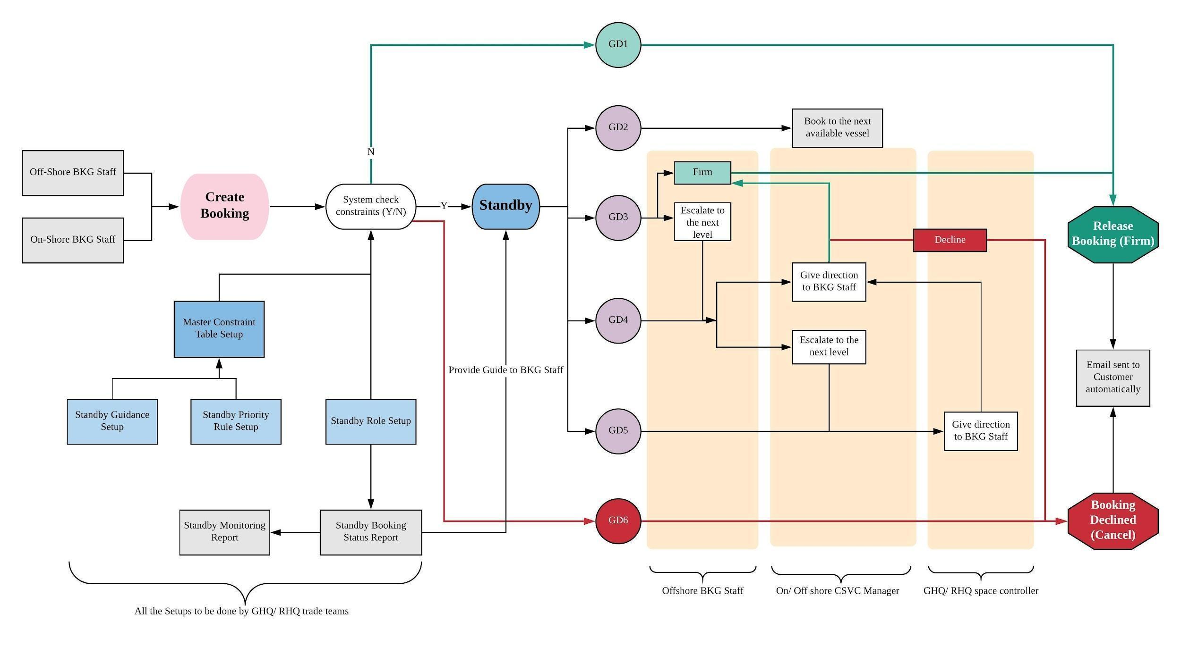
When On/ Offshore booking staff creates a booking, the system will check for any restrictions/ constraints that were set up by GHQ/ RHQ trade teams. If there are no restrictions/ constraints, the booking will become firm instantly. If there are any restrictions/ constraints related to allocation/ EQ/ commodity, the booking will be escalated to the respective party to review and make a decision.

Setup | Responsible party
Master Constraint Table Creation | GHQ/RHQ Trade Teams  (Different setup can be done by Region)
Standby Guidance Setup | GHQ/RHQ Trade Teams  (Different setup can be done by Region)
Standby Priority Setup | GHQ/RHQ Trade Teams  (Different setup can be done by Region)
Standby Role Setup | Regional BPIT

1.3 Roles
There are Three Tiers of business roles. Tier 1 is the On/ Off-shore CSVC manager, Tier 2 the On-Shore CSVC manager and approvers, and Tier 3 GHQ/RHQ Space Controllers.
In the booking escalation process, the booking will be escalated to Tier 2- On-Shore CSVC Manager and approvers. Tier 2 will guide back to Tier 1, and Tier 1 will then be able to Firm or Cancel the booking. Please refer to the Booking Office Tier and Role table.
Booking Office Tier and Role
Business Function Team | Business Role | OPUS SPC Tier | OPUS SPC Role | OPUS SPC Definition
On/Off-Shore Booking Team | -Data entry  -Confirm booking if no constraints
On/Off Shore CSVC Manager | -Data entry  -Confirm booking if no constraints | Tier 1 | BKG | On/Off Shore CSVC Manager
On Shore CSVC Manager/ Approvers | -Confirm bookings escalated from Off-Shore Booking Staff | Tier 2 | BKG | On Shore CSVC Manager/ Approvers
GHQ Space Control (Singapore, Hong Kong & Shanghai) | -Confirm bookings escalated from On shore Booking Office. | Tier 3 | SPC | GHQ/ RHQ space control, Marketing/ Equipment Manager in GHQ/ RHQ

1.3.1 Roles Explanation
Standby Booking Roles can be set up by GHQ/RHQ/BKG office User IDs in Booking/Documentation- Standby Booking Role Setup. For instance, in EA/SA, there are Three Tiers of roles, each Tier represents different type of User IDs, from On/Offshore Booking Staff to GHQ/RHQ Space Controllers.
(Service mgmt->booking/documentation->setup->standby booking role setup)
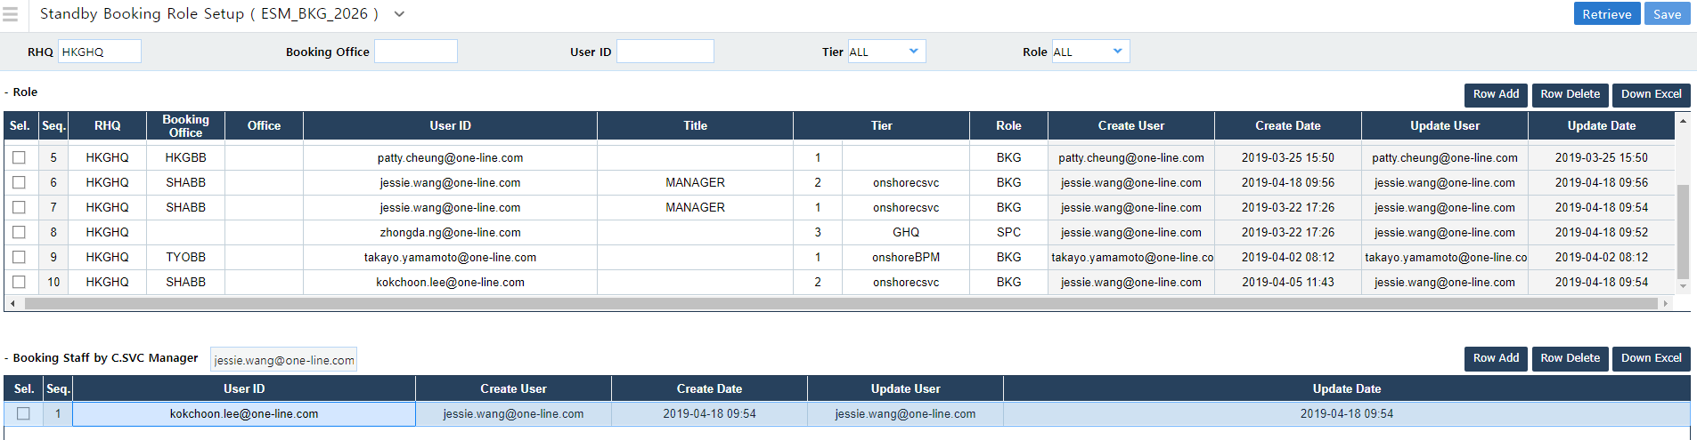

1.4 Process Steps

1.4.1 Space Control – Data Setup

1.4.1.1 Standby Guidance Setup

Standby Guidance Setup
Guide Type | Final Guidance | Default BKG Status | Definition | Authorised party
GD1 | OK to Book | W_F | Booking will be released by Off/ On Shore BKG staff after checking local constraints
GD2 | Book to next available vessel | W_S | Booking will be 1) Standby,and escalate to On-shore or 2) Firm, and roll to the next available vessel
GD3 | If necessary, escalate to CSVC manager (On/Off SHore) | W_S | Offshore BKG Staff can choose 1) Firm or 2) Escalate to the next level | Offshore BKG Staff
GD4 | Escalate to CSVC manager | W_S | On/ Off shore CSVC Manager can 1) give direction to Offshore BKG Staff (Ok to book/ Cancel) 2) Escalate to the next level | On/ Off shore CSVC Manager
GD5 | Escalate to RHQ and GHQ Space controllers | W_S | GHQ/ RHQ space controllers will give direction to On/ Off shore CSVC Manager (Ok to book/ Cancel) | GHQ/ RHQ Space controller
GD6 | Decline | X | Booking will be cancelled automatically
GDN (Special guidance in Priority Rule Setup) |  |  | Trunk-Loading/Customer is within allocation.

1.4.1.2 Standby Priority Setup Creation
The setting of Priority rule is crucial, different ways of setting will result in different Final Guidance. SINHQ’s Priority rule setup is standardised and applied to all Trades, including both HKGHQ and SINHQ. Asterisk (*) stands for all possible Guides (example GD1-GD6 and GDN).
Each region (example RICHQ, SAOHQ, LONHQ) also has their own set of Priority Set-ups depending on their business requirements.
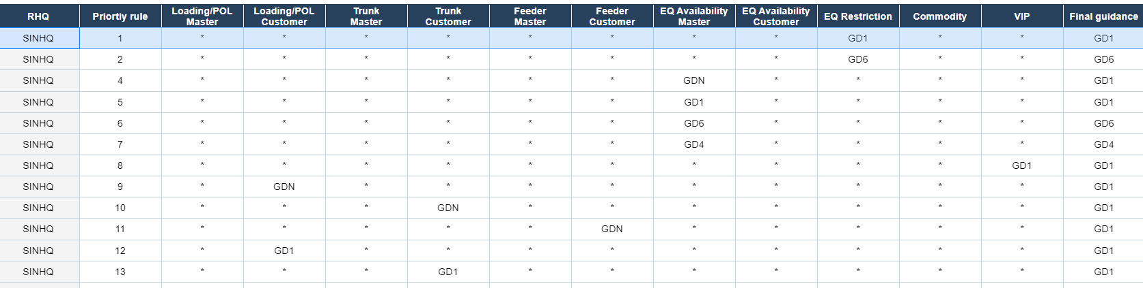

Priority rule 1: If EQ Restriction is GD1, Final guidance will be GD1.
Priority rule 2: If EQ Restriction is GD6, Final guidance will be GD6.
Priority rule 3: If EQ Restriction is GD4, Final guidance will be GD4.
>Deleted as SINHQ will use Sequential Logic that covers Rule 3
Priority rule 4 & 5: If EQ Availability Master is GDN/GD1, Final guidance will be GD1.
Priority rule 6 & 7: If EQ Availability Master is GD6/GD4, Final guidance will be GD6/GD4 respectively.
Priority rule 8: If VIP is GD1, Final guidance will be GD1.
Priority rule 9: If Loading/POL Customer is GDN, Final guidance will be GD1.
Priority rule 10: If Trunk Customer is GDN, Final guidance will be GD1.
>Loading/POL Master = Trunk-Loading Tab Constraint
>Loading/POL Customer = Customer Tab Constraint with Loading Port/POL set-ups
>Trunk Master = Trunk-Overall Tab Constraint
>Trunk Customer = Customer Tab Constraint with VVD allocation set-ups
>Feeder Master = Feeder Tab Constraint
>Feeder Customer = Customer Tab Constraint with Transhipment set-ups

1.4.1.3 Sequential Validation
Sequential Validation checks Master Constraint Table Tabs like a decision-tree flow chart. Instead of checking all constraints simultaneously and using the Priority Rule Table to determine final guidance, Sequential Validation checks a Constraint Tab before moving on to the next Tab, thus allowing multiple constraints to be considered for a final guidance.
Commodity Restriction will be checked first, followed by EQ restriction, then EQ availability, and finally for Trunk-loading, Feeder and Trunk-overall (Master Tab and Customer Tab).
Sequential Validation can be activated or deactivated in the Standby Priority Setup Creation screen.
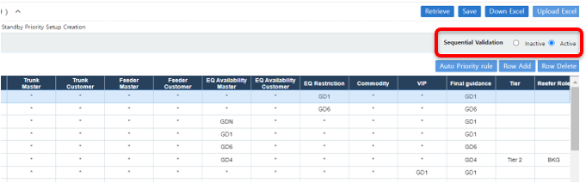
When activated, Standby Priority Set-up Creation Table (1.4.1.2), Sequential Validation Logic (1.4.1.3) and Trade Teams’ set-up in Master Constraint Table (1.4.1.6) work together to derive the Final Guidance for a booking. If deactivated, Final Guidance will be derived by Standby Priority Set-up Creation Table (1.4.1.2) and Trade Teams’ set-up in Master Constraint Table (1.4.1.6) only.
Currently SINHQ and RICHQ are using Sequential Validation as follows;
Sequential Validation Flowchart

1.4.1.4 Standby Revalidation Logic
Bookings that have already gone through Standby and given guidance can be revalidated by the system based on the Hard Coding Setup Table. If Validation is “N”, a change in the booking item (example POR) will not cause a revalidation. If Validation is “Y”, a change in the field (example DEL) will cause the booking to be revalidated.
However, revalidation will not work when the booking item is updated using the Group VVD/Port Assign UI.

(Service Management > Booking/Documentation > Setup > Hard Coding Setup)
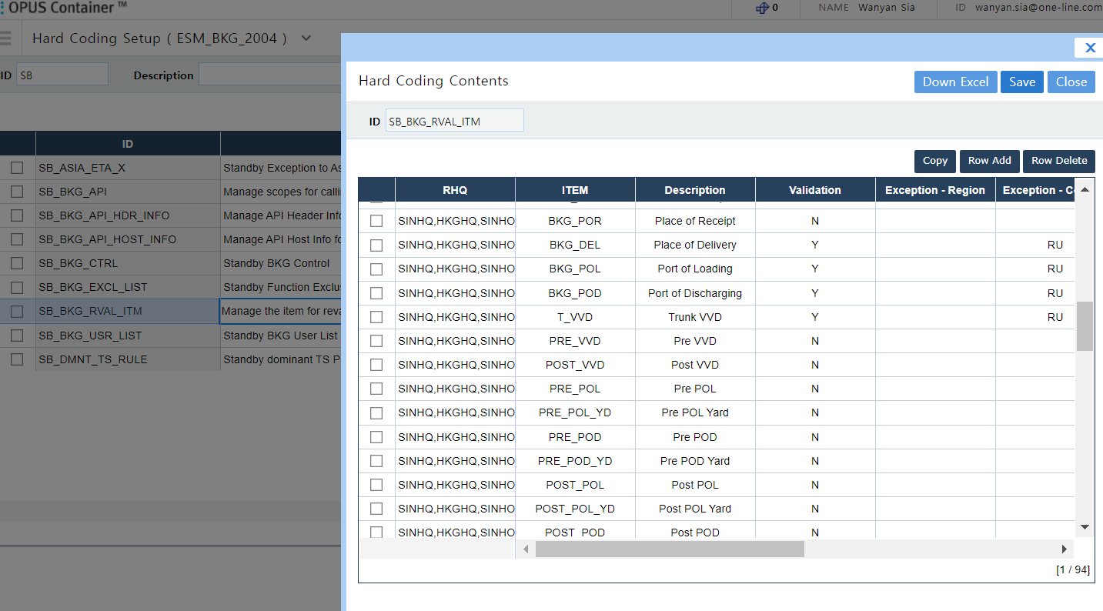

1.4.1.5 Booking Status Definition
In the Booking screen, there are Two boxes representing the status. The first box is the status of the booking itself, and the second box is the Standby status.
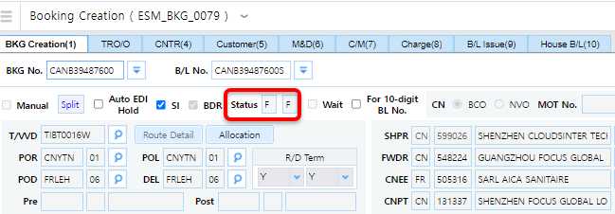

Status | Definition
F/ | Booking is firmed with no constraint
F/F | Booking is firmed through Standby
W/F | Booking Waiting/ Standby Approved
W/S | Booking Waiting/ in Standby
W/X | Booking Waiting/ Decline advised
X/X | Booking is Cancelled due to Decline

*F/blank in Asia means booking is not validated by Standby. In most cases, the user is not registered in the Standby Hardcoding table. In some cases, due to other system errors.
When a booking is Standby, the normal booking process is suppressed.
- Trans Request Order on Booking Creation
- FAX/EDI on Booking Creation (Booking Receipt Notice, Draft BL etc.)
- Booking Receipt Notice (Fax/Email)
- Booking Receipt Notice (EDI)
- Booking EDI Transmit to Terminal
- Empty Container Release Order
- VGM Dashboard

1.4.1.6 Master Constraint Table Creation
Master Constraint Table allows GHQ/RHQ trade teams to have an overall management of space allocation and constraints by Trunk-Overall, Trunk-Loading, Feeder, EQ, Commodity and Customer. GHQ/ RHQ Trade teams can update constraints and customer Account Plan in the Master Constraint Table.
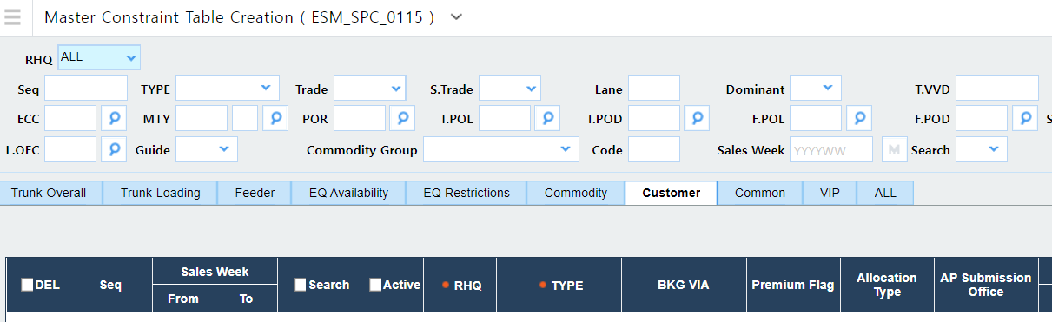
Trunk-Overall
Trade Teams can set Trunk vessel’s threshold % at trade level. For instance, FE2 WB Trunk vessel threshold is set as 85%, if actual booking volume is over 85%, GD4 will be triggered. Remarks will be shown in the standby popup detail page.
Trunk-Loading
Trade Teams can also set the Trunk-Loading threshold %. For instance, FE2 WB, Loading office NBOBB exceeds threshold % of 110%, GD4 will be triggered. Remarks will be shown in the standby popup detail page. Allocation also can be set by port pairs with TEU allocation and threshold %.
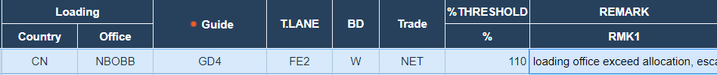
Customer (with <>7 or 10 days logic) in Asia
Customer Account Plan can be downloaded and uploaded from and into the system by Trade Teams in the Master Constraint Table. Guidance will be triggered when actual booking volume is above customer allocation.
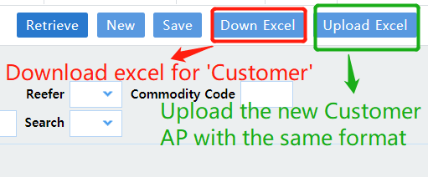
There is also a 10-day logic in Master Constraint Table, the Final Guidance can be different when the booking is created more than 10 days before the first VVD’s ETA, and less than 10 days before the first VVD’s ETA (Count by hour: 1st VVD ETA - 10*24 hours).
For example, if the below booking is created more than 10 days before the first VVD’s ETA, the booking will be GD1. However, if it is created less than 10days before the first VVD’s ETA, booking will become GD4.
Constraint Type |  |  | Threshold % | Actual Booking | Guide | Guide (ETA-10)
Trunk Overall | ABCD0001W |  | 100% | 98% | 4 | 4
Trunk Loading | SHABB |  | 100% | 95% | 4 | 4
Customer | XYZ00008A | 10 TEUs allocation |  | 9 TEUs | 4 | 4
Final Guidance |  |  |  |  | GD1 | GD4

Customer GD4 Hard coding for Asia
- Customer without allocation.
- S/C or RFA info is not available in the Master Constraint Table.
- Only apply to OCN bookings.
Weight Allocation
Set-up can be done via TEU or Total WGT allocation. Additional Average WGT MT/TEU per booking is also available under the Customer tab. Trades are also able to indicate if the WGT allocation is inclusive of tare weight by checking the “Add Tare Weight” box.
Tare weight is derived from OPUS Master Data for the specific container Type Size.
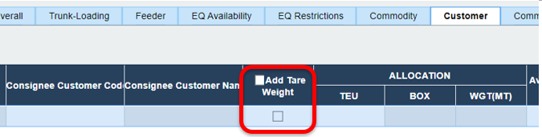
Common constraint
General comments/ guidance will be shown. However, the common guidance will not affect the Final Guidance.
Validation Error Pop-out Table
When users upload constraints using the "Upload Excel '' button, a validation error table will pop-out and identify the fields and possible reasons for errors. Line numbers in the Validation Error Table correspond to the Row numbers in Excel file. Excel file will have to be cleared of the errors, and reuploaded before the constraints can be saved in the Master Constraint Table.
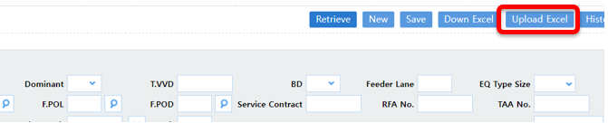
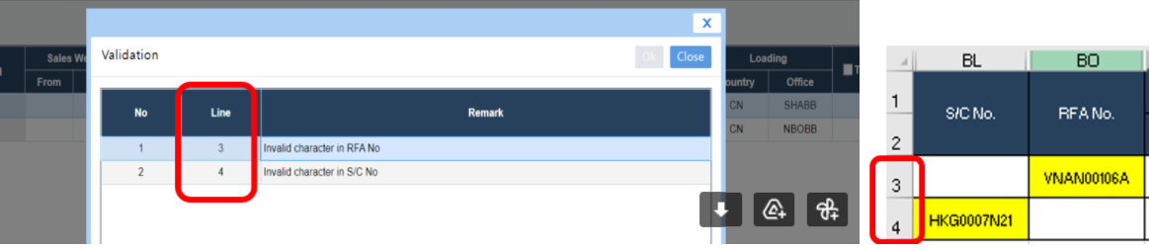

Exact Match checkbox in EQ Restriction, EQ Availability & Customer Tabs

Exact Match checkbox allows users to specify whether a particular constraint is strictly applicable for a certain container type/size only and would not allow the release of any mixed bookings.

For example, a constraint with RF flag and Exact Match flag checked will not allow the release of mixed booking of 1xR5 and 10xD4.
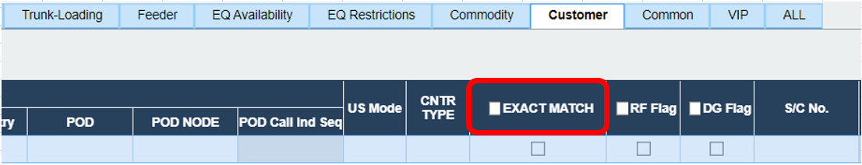
Move Count Field in Trunk-Loading, EQ Restriction & Customer Tabs
This field gives users the option to control the move counts by indicating the limit under the “Move Count” field. The move count logic is also based on the total number of containers, not by total teu.
For example, a booking with 2xD4 is equal to 2 move counts. And if a constraint is created with a limit of 5 move counts, the booking will be guided as GDN as it is within the limit.
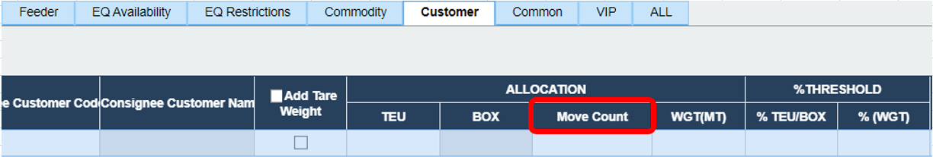
% Threshold in Customer Tab

The % threshold allows Trades to control the % of excess AP to release without changing the initial Account Plan numbers in case of high shortfall situations.

For example, allocation is 50 teus and % threshold is 200. The total bookings that can be released under this constraint will be 100 teus.

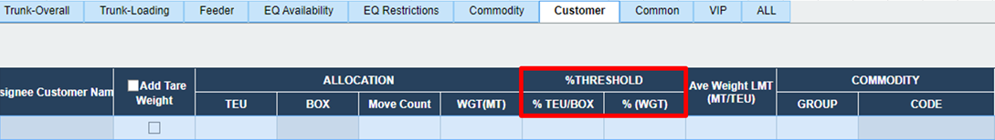

Code Field in Feeder Tab
This field allows users to input or select “PRE” to set Pre-feeder constraints or “POST” for Post-feeder constraints in Feeder tab.
The final guide will be based on a Priority approach: GD6> GD2> GD3> GD5> GD4> GD1/ GDN.
If “PRE/ POST” field is left blank, it will depend on Opus logic to decide if it is a PRE or POST Feeder.
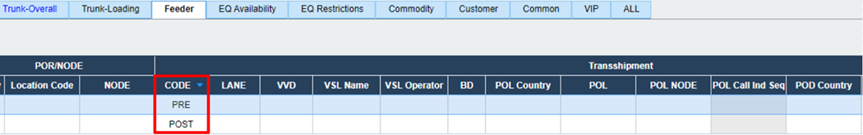
Utilization Calculation Pop-Out in Master Constraint Table
This function allows users to check the constraints utilization which help users give updated directions or adjust the constraints if necessary. The “Utilization” button is available on all tabs except for Commodity, Common and VIP tabs, and for this button to appear, the “Select” button must be clicked first.

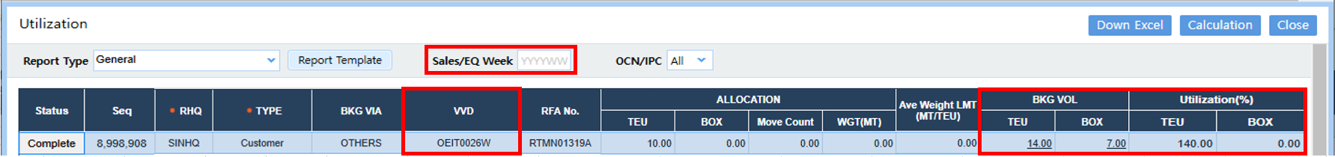
E.g. Utilization calculation pop-out generated 14 teus for SEQ 8998908 as it captured below bookings. Utilization/ BKG VOL will be calculated automatically when VVD is available. If it is not, Sales/ EQ Week must be inputted in the pop-out to trigger the calculation.
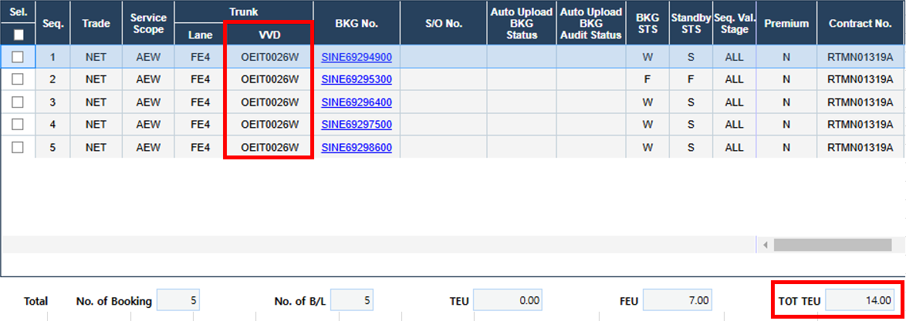

Soft Warning Pop-Out in Master Constraint Table
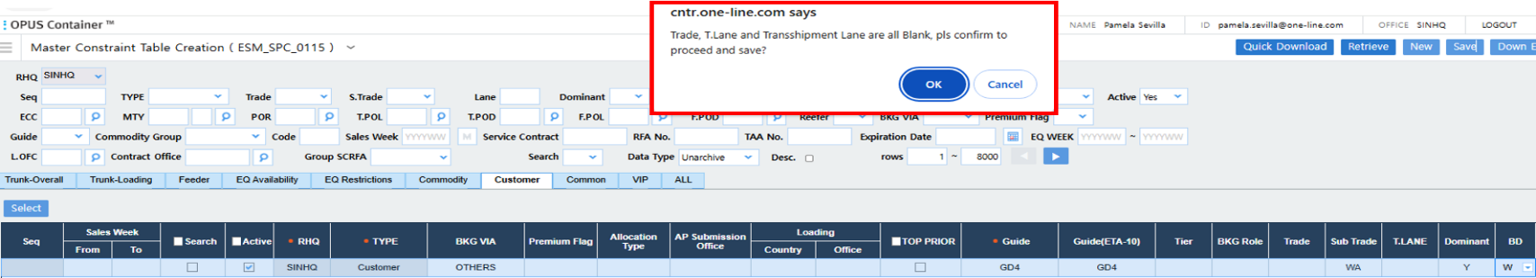
The soft warning pop-out will appear when users create constraints with blank Trade/ T.Lane/ Transshipment Lane and when each line is registered in MCT directly (there is no validation for excel upload). And since this is only a soft warning, users can still save the constraint if they click OK to proceed.

Improve Master Constraint Table Performance with Backend Archiving Logic
There were some performance issues in the MCT UI as all non-deleted constraints were kept in the Standby Live Database even though they were not being used for current standby calculation, as VVDs have long sailed. So, in order to improve its performance, a backend Archive flag or logic was added so that the past data can be moved to the Standby History database via a weekly batch.
The criteria for the weekly archive data batch are as follows:
- Customer Tab
- Only for constraints with 1 VVD input
- Based on last update date 4 months from current (only archive 4 months after a constraint’s last update date)
- Include BKG via WEQ, OTHERS and Blank
- EQ Availability Tab
- Only for constraints with EQ Date/ Full Cut Off To
- Only archive if “EQ Date/ Full Cut Off To” has passed during weekly archive batch
Standby judgement/ validation will refer to Standby Live Database only.
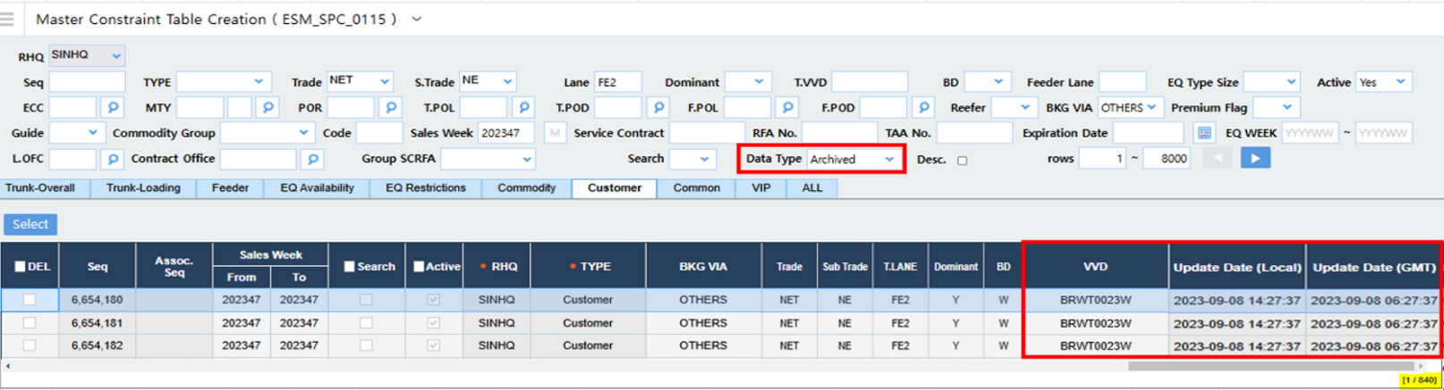
E.g. Retrieved 840 Archived constraints under FE2 service for 202347 and all the constraints have 1 VVD input and were updated more than 4 months ago.

Update in Standby Logic for SINHQ/HKGHQ/DXBHQ
Previously, standby judgement considered all Firm and Waiting bookings which resulted in bookings going to GD4, even though there may be no firm bookings or limited number of firm bookings compared to the allocation.
So, the Standby logic has been updated wherein it will only consider the total of self booking plus;
- Firmed Booking Status
- GD1 bookings that are not firmed yet (status W/F) due to further checking required for OOG/DG or other hold status by offshore/ onshore etc.
- Other Standby Guide (e.g GD2/GD3/GD4/GD5) bookings that are currently in Waiting/ Standby status (W/S) or W/Blank or W/E status, but already guided by onshore to Firm (only pending action to firm it)
E.g. Below bookings were created before the AP was set up so all bookings went to GD4
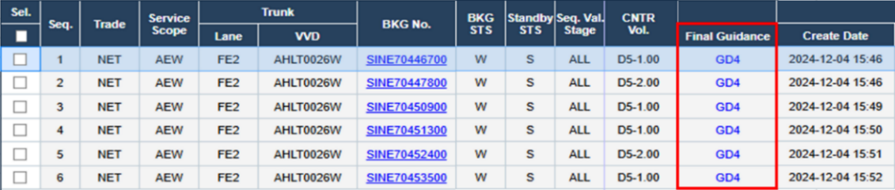
Once the AP (12 teus) was set up, user recalculated all the bookings at the same time. After recalculation, they received below final guidance.
- If there are more than one booking selected for recalculation, system will guide them on first-come-first-serve basis depending on the booking creation time.
- Booking SINE70452400 went to GD4 as set up allocation was already exceeded. While the next booking SINE70453500 went to GD1 as it is still within the balance space.

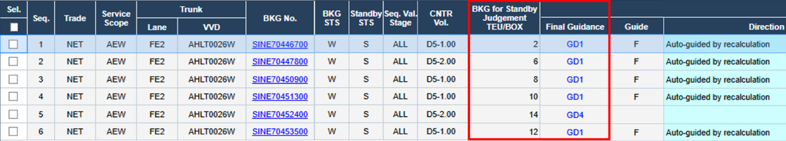
Below fields were also added in the Standby Booking Status Report
- BKG for Standby Judgement TEU/Box / TONS
When “Current TTL TEU Calculation” is clicked, below fields will appear
- Current BKG for Standby Judgement TEU/Box / TONS
- Current Standby Firm/ Guided Firm TEU/Box /Tons
- Current Standby Wait TEU/Box / TONS

Spot/ Non-Spot AP Constraint in Customer Tab

Spot and Non-Spot AP constraints were added in MCT Customer tab, which allow users to exclude AP volumes from Spot volumes and allow booking release judgement to be totally separated between Spot and AP.

Spot will be used for creation of a spot allocation and will act as a “Parent” sequence of Account Plan. While the Non-Spot AP will function in a similar way to “Customer”, however it is the “Child” of the Spot constraint which means that it would not be possible to create a Non-Spot AP constraint without creating a Spot constraint first.
In total, there are now three types in Customer Tab (Customer, Spot, and Non-Spot AP) and the Judgement Priority is Customer > Spot/Non-Spot AP. However, it is suggested to only use either the Customer Constraint OR Spot/Non-Spot AP constraints to avoid getting the wrong result.

E.g Below constraints were created in Customer Tab.
Booking SINE05512600 referred to SEQ 7306068 as the RFA No. match.
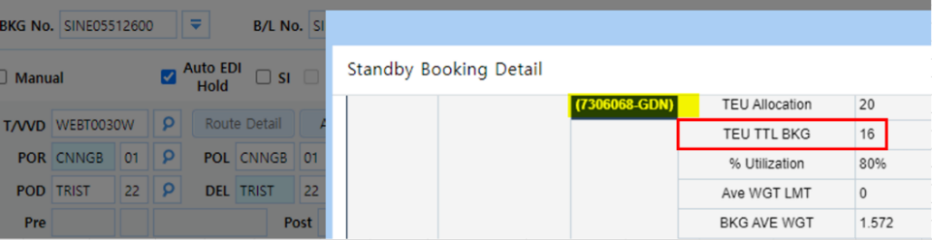

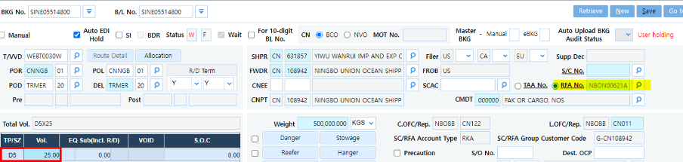
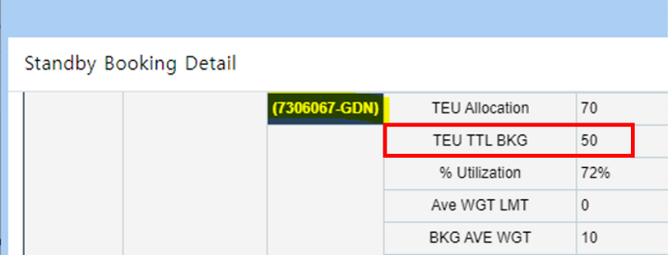
While booking SINE05514800 referred to SEQ 7306067 as RFA No. NBON00621A is not a part of Non-Spot AP constraint. Non-Spot AP volume was also excluded from the Spot volume.

1.4.1.7 Creation of Group RFAs
Multiple SC/RFAs can be grouped into a single GRFA. Allocation set for GRFA will be shared by the single SC/RFAs within the group. The grouping setup is to be done by Trade.
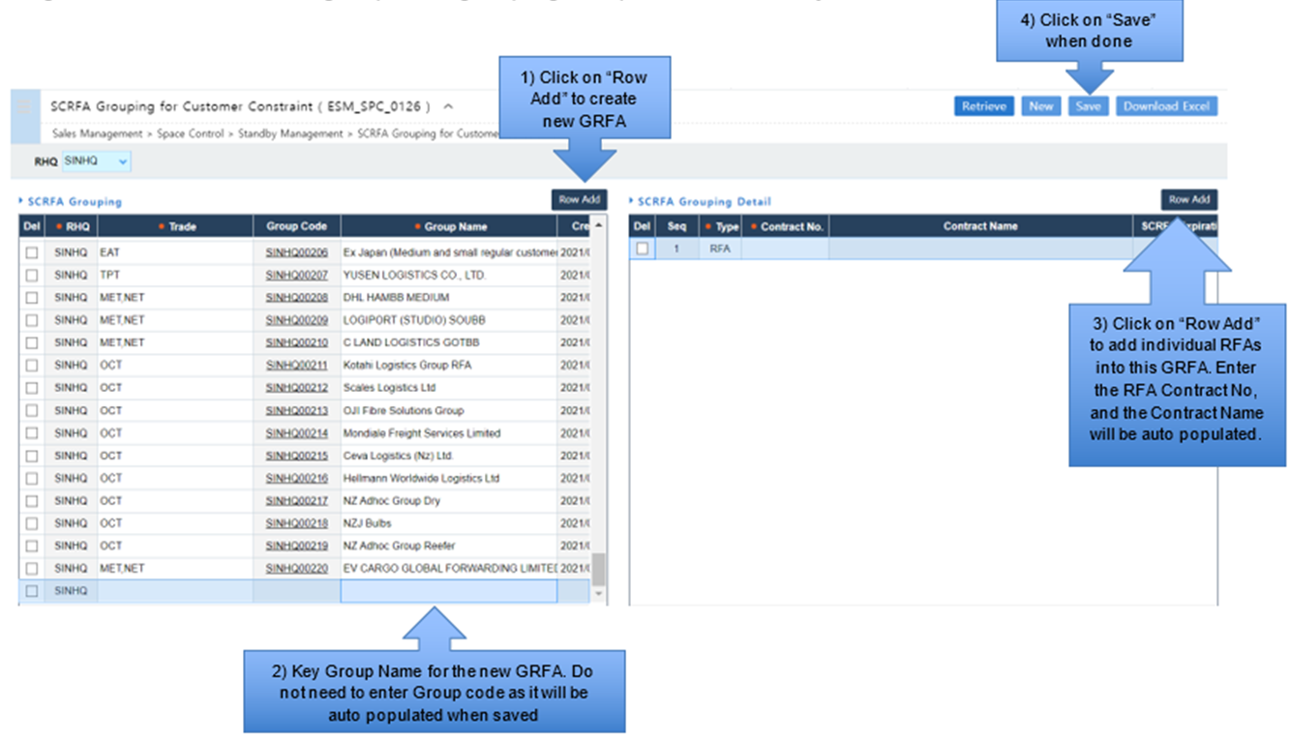

1.4.1.8 Standby Hardcoding Table for Pre/Post Feeder
OPUS Standby judgement logic for Feeder Tab constraint is based on the Dominant or Non-Dominant leg. For a Dominant leg, Feeder logic is based on the pre feeder. While for a Non-Dominant leg, Feeder logic is based on the post feeder. The set-up in Feeder Tab must match OPUS Standby’s logic or the constraint will not work to control the Feeder bookings.
However, it is possible to change the Standby Feeder logic on a GHQ/RHQ, Trade or Lane basis, using the Hard Coding Setup Table.
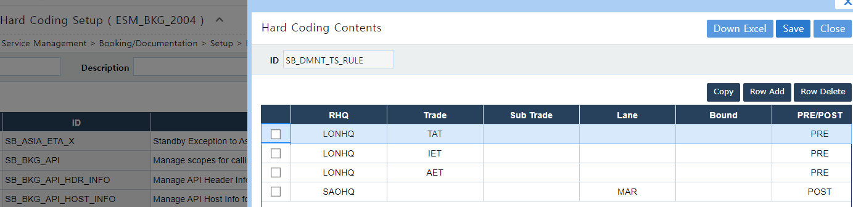

1.4.2 Booking/ Documentation

1.4.2.1 Standby Booking Status Report
Standby Booking Status Report gives everyone a fast view for the Final Guidance advised and other data to assist in determining if the booking is approved or declined.
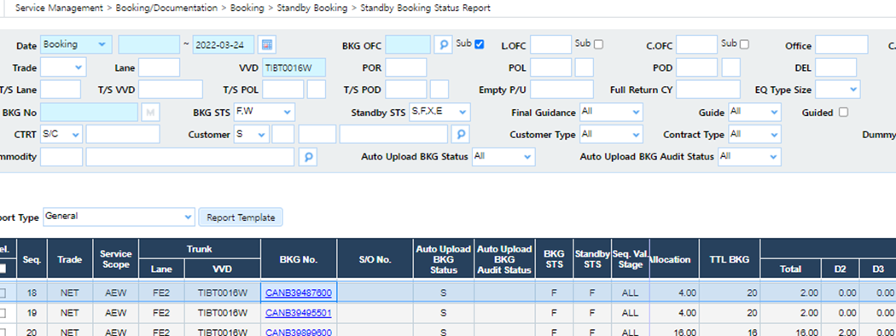
All the standby bookings can be retrieved in the Standby Booking Status Report, with Standby reason, current Tier/Role and Direction given. Tier 2 and Tier 3 users will be able to send their guidance (Firm/Cancel/Direction/Firm as Rollpool/Comment) to BKG staff when the booking is being escalated to their Tier/Role, BKG staff are then able to confirm or cancel the booking.
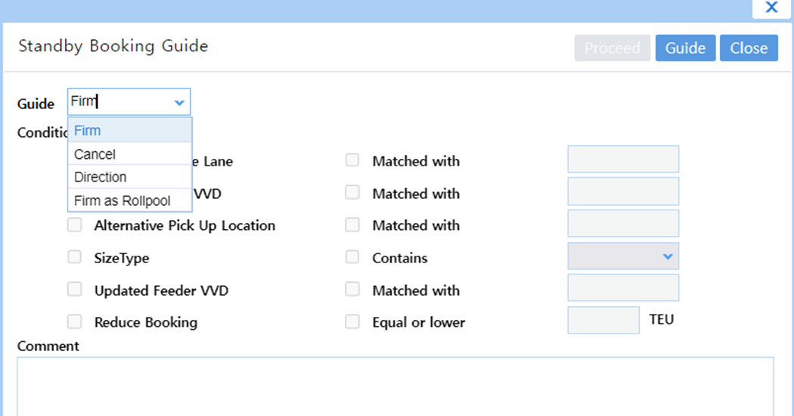
In the Standby Booking Status Report, CM/Teu and Ave CM/Teu information are also available for bookings assigned with Standby Status: S, X or E. This is designed to help users in their decision-making during booking release.
CM/Teu (EPP-A or B) = [Ocean Freight (OFT) + Surcharge (SUR) – Cost (EPP-A or B)]/Total Teu
However, around 40-50% of the bookings have “No Rate” in the CM/Teu calculation due to no applicable rate for the contract, or no applicable rate for the container type size of the contract when the booking was created.
For such cases, Users can refer to the Ave CM/Teu (EPP-A or B) instead. Calculation of Ave CM/TEU is based on bookings with application dates of 3 months before the PF First POL ETD date. And considers Service Scope, Revenue Lane and SC/RFA number. For example, when Standby was validated, the PF First POL ETD is on 21/Mar/2021. Then the Ave CM/TEU will be calculated based on bookings with Application dates from 20/Dec/2020 to 20/Mar/2021.
Detailed information regarding CM/Teu and Ave CM/Teu calculation logic in Standby Booking Status Report can be found in this guide.

1.4.2.2 Standby Booking Monitoring Report
In the Standby Booking Monitoring Report, total booking volume can be retrieved by Trade/ Dominant leg/Bound/ VVD, including all Firm/ Waiting/Standby/ Error bookings.
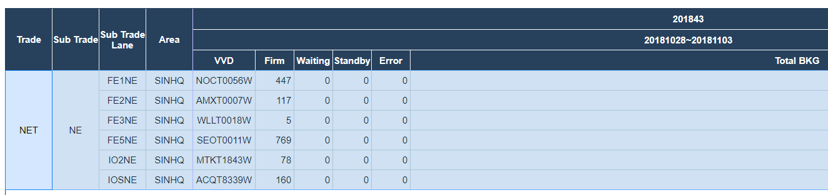

2. Business Rules

2.1 Standby Priority & Guidance Setup – Business Rule Interpretation
Please refer to 1.4 Process Steps

2.2 Final Guidance, Escalation, Decision Making Authority

2.2.1 Country with Off-shore Booking Team
Please refer to 1.4.1.1 Standby Guidance Setup

2.2.2 Country without Off-shore Booking Team
Please refer to 1.4.1.1 Standby Guidance Setup

2.2.3 Trade-specific booking release process

2.2.3.1 AET

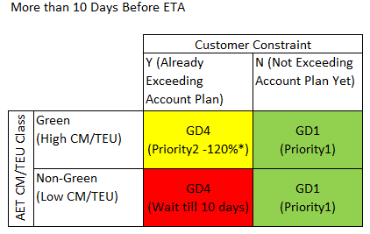
- Within the Account Plan, can release instantly.
- For Green customers, give discretion to release up to 120%(*) of AP
- For Non-Green customers, need to wait till 1
- 0 day cut off for beyond-AP portion.
* varies by trade direction

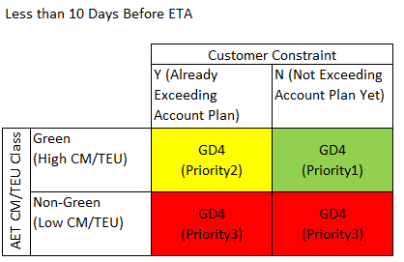
- Passing 10 day cut-off, release all Green "standby" booking accumulated so far.
- For Green customers, if sales forecast(**) tells it's coming later, need to reserve space till last minutes
- If there are still remaining space, can start release Non-Green customer "Standby" bookings
** Sales forecast is very important to protect Green customer space after 10 days.

3. ONE Quote Standby Functions

3.1 ONE Quote Allocation Set-up

3.1.1 BKG VIA field
Under the Customer tab, trades can set allocations for ONE Quote bookings through the “BKG VIA” column by selecting “WEQ”.
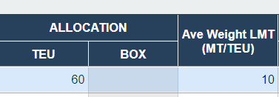

3.1.1.2 BKG VIA filter
For easy access, trades are also able to utilise the “BKG VIA” filter to check WEQ constraints in the Master Constraint Table.
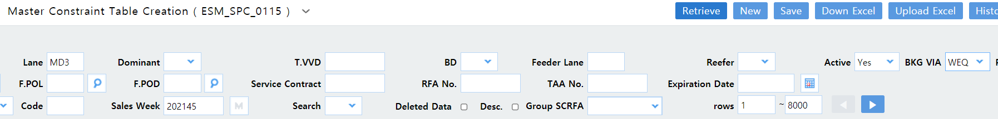

3.1.2 POR/POL/POD/DEL Allocation
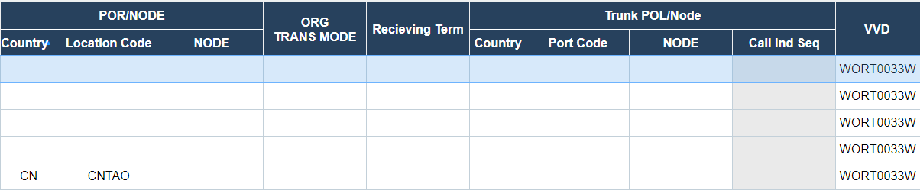
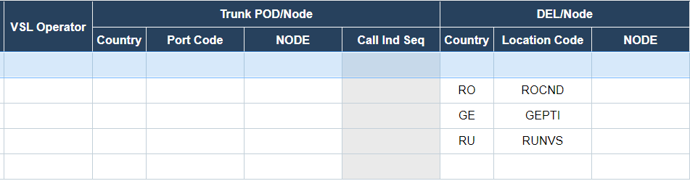
ONE Quote allocations can also be set by POR/POL/POD/DEL.

3.1.3 ONE Quote Standby Guidance and VVD removal from Platform
If total bookings exceed the allocations set under 3.1.1 and 3.1.2, bookings exceeding the threshold will go into GD6 for rejection should trade set-up specific allocations as GD6.
VVDs will also be removed from ONE Quote platform (closed) if total bookings exceed allocations at the time of judgement.
Scenario 1
If WEQ allocations are set as GD6.
 | Trunk Overall | To/From POR/POL/POD/DEL
Allocation | 1000 | 300
Total ONE Quote Bookings | 1020 | 200
Standby guidance | GD6 | GD6 (as total trunk is full)

Scenario 2
If WEQ allocations are set as GD6.
 | Trunk Overall | To/From POR/POL/POD/DEL
Allocation | 1000 | 300
Total ONE Quote Bookings | 800 | 310
Standby guidance | GD1 (exclude bookings exceeding POR/POL/POD/DEL) | GD6

3.1.4 Premium Flag Field
Premium flag allocation can be set under the premium flag field.
Scenario 1
Total WEQ allocation for all customers (with and without premium flag) at 200teus.
Bookings will go to GD6 once hit the threshold above 200teus
Scenario 2
Total WEQ allocation non-premium customers at 50teus.
Total WEQ allocation for all customers (with and without premium flag) at 200teus.
If total bookings for non-premium customers is only at 15teus, premium customers can load up to 185teus.

Scenario 3
Total WEQ allocation premium customers at 50teus.
Total WEQ allocation for all customers (with and without premium flag) at 100teus.
Premium customers can load up to 50teus before hitting the threshold for escalation.
Should there be nil premium bookings, maximum for non-premium customers would be up to 100teus.

Scenario 4
For cases where only premium cargo is offered in ONE Quote, the set-up as per Scenario 1 will be sufficient. I.e. Premium flag “blank” in Standby.
Detailed information regarding ONE Quote Standby Set-Up can be found in this guide.

4. Supporting Information

4.1 System Manuals
Notes by CLT
How to Guide by NA
ONE Quote Standby Set-up Guideline

4.2 Additional Documents

4.2.1 Test Scenario (Asia)

4.2.1.1 Scenario 1: Trunk Overall
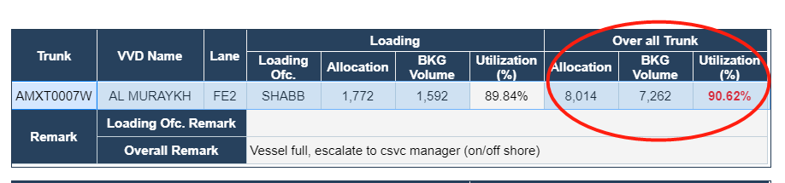

4.2.1.2 Scenario 2: Trunk Loading
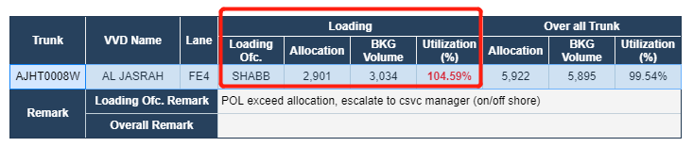

4.2.1.3 Scenario 3: Customer
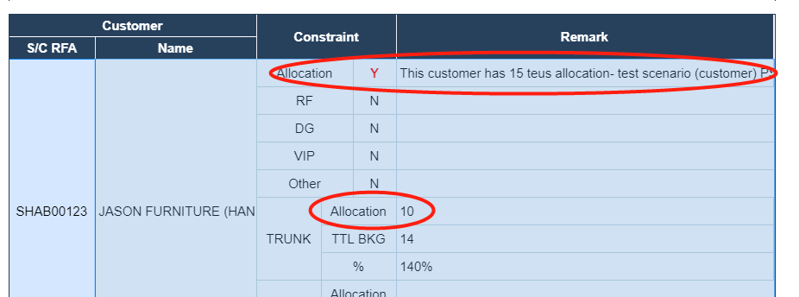

4.2.1.4 Scenario 4: Common


4.2.1.5 Scenario 5: 10 Days Logic
Below sample booking has the creation date less than 10 days to the first VVD’s ETA, therefore, even though Trunk-Overall, Trunk-Loading, and Customer are all within allocation, due to the setup of 10 days function, Final Guidance will still become GD4 (Escalate to CSVC Manager).
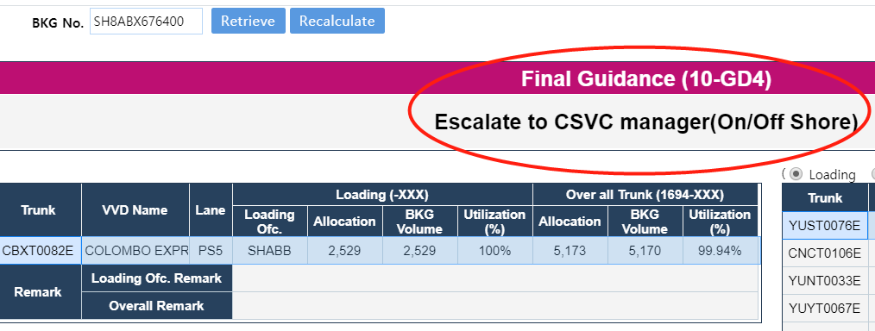
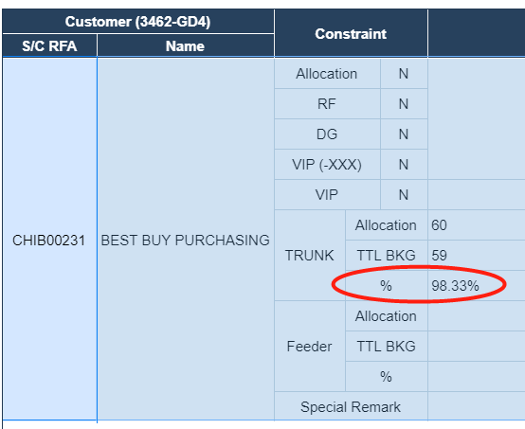

4.2.2 Launch Status – Countries and Trades
Refer to Standby New Matrix.

4.2.3 Asia Booking Process
Booking Acceptance Priority Rules under Standby Function
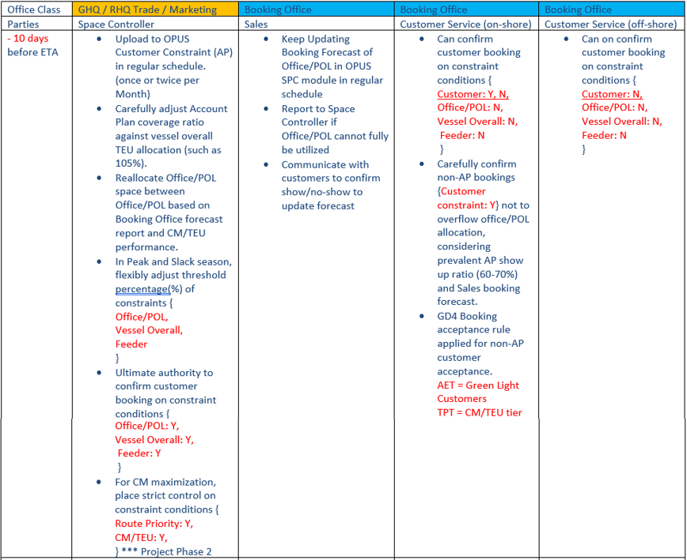

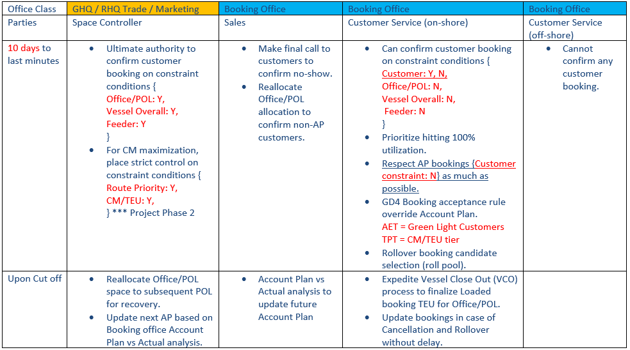

4.2.3.1 Split/ Combine/ NROF bookings
Booking Split
In case of booking split, if the original booking is already Firm or blank, standby logic will not be running. However, if the original booking is standby status, standby logic will be running when booking is split.
Booking Combine
In the case of Booking combine, if the booking status of all original bookings are Firm or Blank, standby logic is no longer required because it's already firmed. However, if one of the original bookings or all original bookings are standby status, standby logic will be running

No Rates on File (NROF) bookings
For NROF bookings, final guidance will become GD4, and escalate to relative parties.
Empty bookings
Empty bookings are not in current Standby Booking scope.

4.2.3.2 Customer over account plan

 |  | System Guidance | Current Process
Customer Allocation | 10teus
Current bookings | 7teus
New booking | 5teus (Over by 2teus) | GD4- The whole lot will be escalated to Onshore | The whole lot will be pending

4.2.3.3 Releasing of GD1 bookings/ Offline checking of Blacklist
At the current stage, GD1 bookings are not released automatically. The bookings are to be manually held and some other constraints/ restrictions are required to be checked offline and manually by offshore booking staff on all GD1 bookings before releasing.

4.3 Glossary
Glossary for OPUS Container

